Rules
by Doug Kent
Choose a Character:
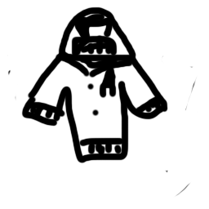
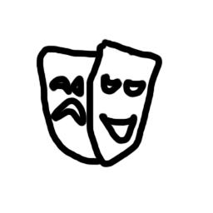

Jock Brainiac Drama Geek

After selecting a character take the corresponding 6 card deck, known as your backpack.
Choose a School;
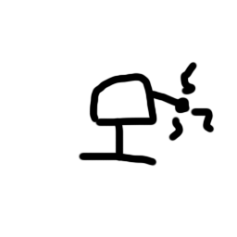
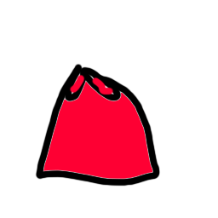
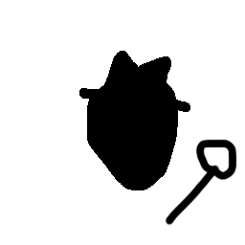
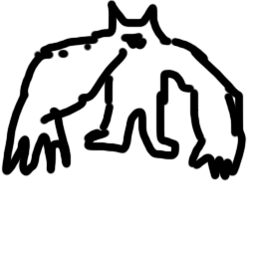
Villain Superhero Spy Monster

Place the particular school in front of the player. If a player selects the villain school, look at the villain section.

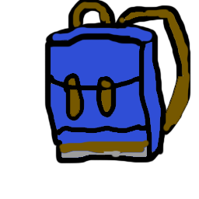
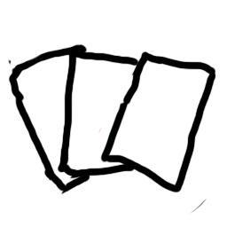

Draw three cards from your backpack.

Turn:



Purchase an item (Optional)
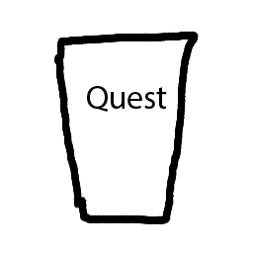
Go on a Quest (Optional)
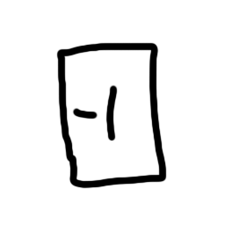

Take an Action (Optional)
4.
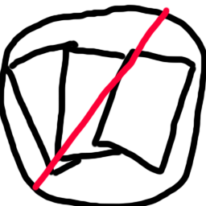
Discard hand and draw 3 cards (optional)

5. End Turn

Item Setup
Deal 6 items face-up on the table, the item cards are the ones with a blank back and are not the school cards. Select the six cards at random. Place the rest of the items aside in a pile.

Purchased Item
Place the purchased item in your discard pile. Pay the amount of money to purchase the item. If you do not have enough money you cannot purchase the item. Can only purchase one item during your turn. Replace the purchased card with an item card from the pile set aside.

Types of Items:
Equip: Place this card in front of the player and they keep the effect.
Action Card: Pay the needed cost, take the action, and place the card in the discard pile.

Go On a Quest
Draw a quest card and attempt to complete the quest. If you believe you cannot complete the quest you can forfeit and sacrifice 2 health. If you forfeit a quest, place it on the bottom of the quest deck. After the quest if you fail or succeed mark if you passed and place the quest on the bottom of the deck.

Types of Quests:
Battle: In a battle quest you alternate turns with the enemy trying to reduce its health to zero. Just like any quest you can forfeit and lose 2 health.
Regular: You roll a die and add the necessary skill and determine if you pass or fail. You can also forfeit these quests by losing 2 health.

Actions:
You have one action each turn. Some cards can grant you more actions.

Victory Conditions:
First player to collect 10 Quest cards.
Last player alive.

Villain
A villain may play their cards that deal damage on other players and other players can play their cards that deal damage on the villain.

